SEC : A WORKING WITH DIRECTORY STRUCTURES BATCH : A3

REG: 190905513 LAB 02 NAME: MOHAMMAD DANISH EQBAL

LAB EXERCISES:

1. Write a C program to emulate the ls -l UNIX command that prints all files in a current directory and lists access privileges, etc. DO NOT simply exec ls -l from the program.

Program:

#include <unistd.h>
#include <stdio.h>
#include <sys/stat.h>
#include <sys/types.h>
#include <dirent.h>

int main()
{
DIR *myDirectory;
struct dirent *myEntryToDirectory;
struct stat statusBuffer;

if ((myDirectory = opendir(".")) == NULL)
{
printf("We can not open the directory.\n");
return 0;
}

chdir(".");
while ((myEntryToDirectory = readdir(myDirectory)) != NULL)
{
lstat(myEntryToDirectory->d_name, &statusBuffer);

if (!S_ISDIR(statusBuffer.st_mode))
{
printf("%s \t \t", myEntryToDirectory->d_name);
printf((S_ISDIR(statusBuffer.st_mode)) ? "d" : "-");
printf((statusBuffer.st_mode & S_IRUSR) ? "r" : "-");
printf((statusBuffer.st_mode & S_IWUSR) ? "w" : "-");
printf((statusBuffer.st_mode & S_IXUSR) ? "x" : "-");
printf((statusBuffer.st_mode & S_IRGRP) ? "r" : "-");
printf((statusBuffer.st_mode & S_IWGRP) ? "w" : "-");
printf((statusBuffer.st_mode & S_IXGRP) ? "x" : "-");
printf((statusBuffer.st_mode & S_IROTH) ? "r" : "-");
printf((statusBuffer.st_mode & S_IWOTH) ? "w" : "-");
printf((statusBuffer.st_mode & S_IXOTH) ? "x" : "-");
printf("\n\n");
}
}
}

Output:

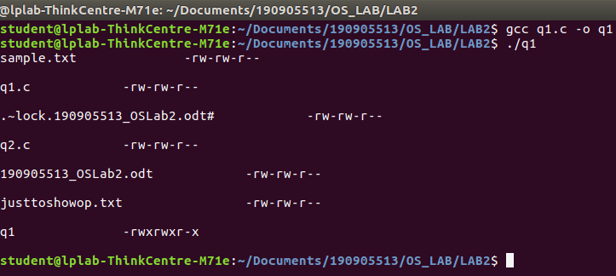

2. Write a program that will list all files in a current directory and all files in subsequent subdirectories.

Program:

#include <unistd.h>
#include <stdio.h>
#include <dirent.h>
#include <string.h>
#include <sys/stat.h>
#include <stdlib.h>

void printDirectory(char *dir, int depth)
{
DIR *myDirectory;
struct dirent *myEntryToDirectory;
struct stat statusBuffer;

if ((myDirectory = opendir(dir)) == NULL)
{
fprintf(stderr, "Directory cannot be opened: %s\n", dir);
return;
}
chdir(dir);

while ((myEntryToDirectory = readdir(myDirectory)) != NULL)
{
lstat(myEntryToDirectory->d_name, &statusBuffer);

if (S_ISDIR(statusBuffer.st_mode))
{

if (strcmp(".", myEntryToDirectory->d_name) == 0 || strcmp("..", myEntryToDirectory->d_name) == 0)
{
continue;
}

printf("%*s%s/\n", depth, "", myEntryToDirectory->d_name);

printDirectory(myEntryToDirectory->d_name, depth + 4);
}

else
{
printf("%*s%s\n", depth, "", myEntryToDirectory->d_name);
}
}
chdir("..");
closedir(myDirectory);
}
int main()
{
printDirectory(".", 0);
exit(0);
}

Output:

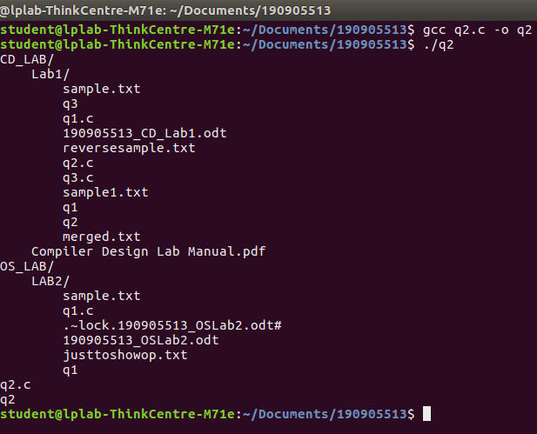

3. How do you list all installed programs in Linux?

Command:

dpkg –l

Output:
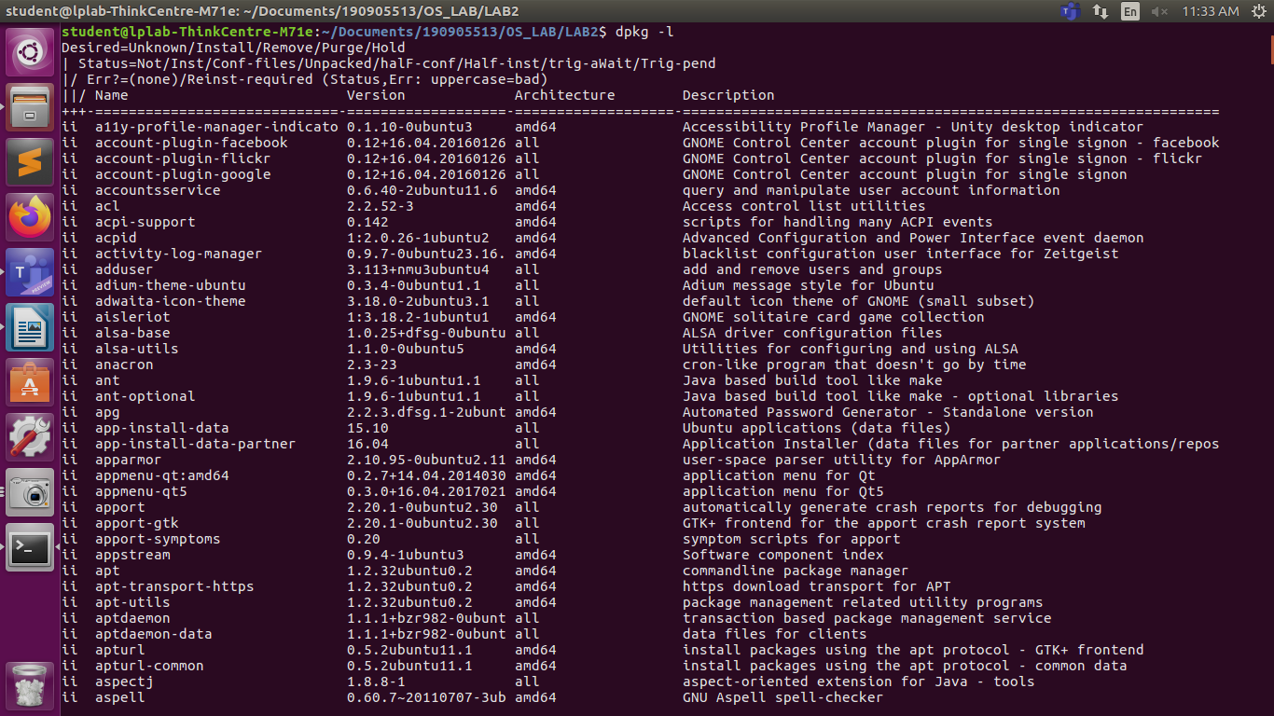

4.How do you find out what RPM packages are installed on Linux?

Command:

rpm -qa

Output:

//RPM packages are not installed OR access to root is not given to the user student on lab’s computer. Hence, cannot show the desired output.

